**NSW RSL Result Management System**

Public viewing page: <https://leaguesrms.com/nswresult>

Welcome to the result management system, where you will find the latest draw and results through out the season.

# Tabs

You can navigation to different areas to get the information you need by clicking on the Tabs header



Home: Current results, ranking, most frame won and high breaks

Players: Player list for each team

Matches: Match listing with result

Teams: Team/Venue List

Gallery: Match photos Gallery

Documents: Where you can download, scoresheets, forms, and documents for the competition.

Comments: Leave a comment or suggestions on system improvements

# Players Handicap

The system automatically adjusts the handicap based on previous match results, captains can navigate to the Team details page to view the current Team’s statistic and player’s handicap before the next match anytime.

# Result submission

At the top right of the Public viewing page, Click on Portal Login



Login with your team’s username and password at the login page

Once logged in, you should see Pending Result for the last match played.

You can submit result for the last match of the club teams played either Home/Away.

You can update matches result by clicking on the red arrow  

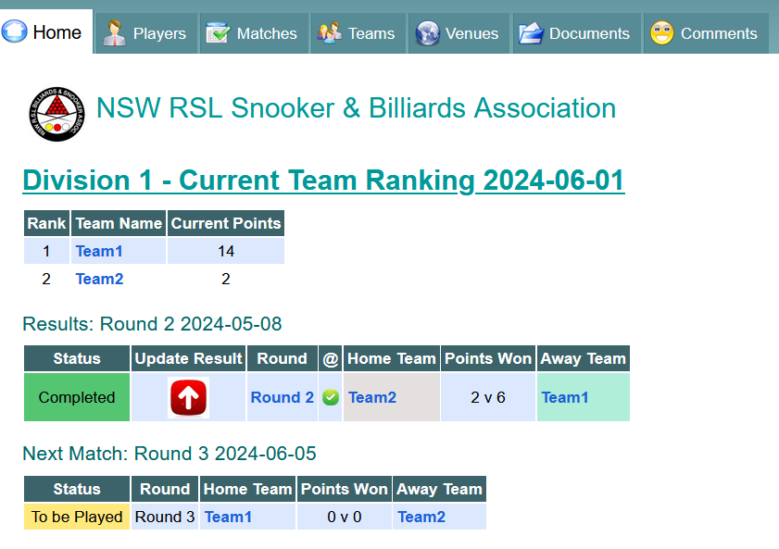

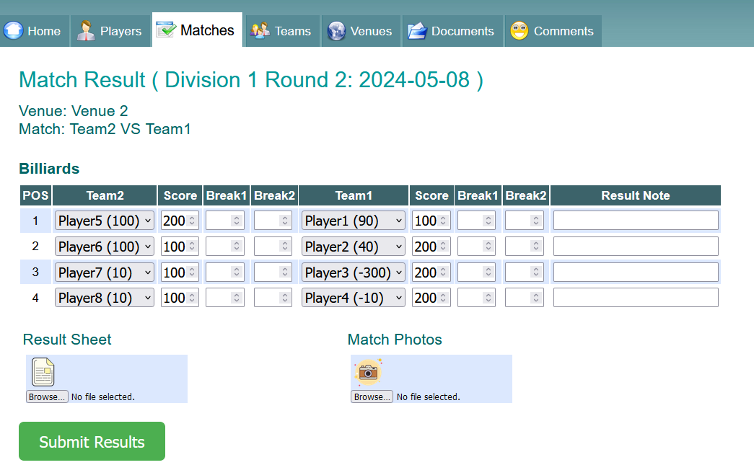

Select the players from the drop-down list, you will see the players belongs to the two teams and the correct handicap next to the player’s name.

Select the Frame scores for both home and away team

Enter the highest break for the match at the Break fields

You can enter a Result Note if something worth noting

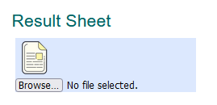

Uploading a photo of the result sheet is critical to verify results.

Click on the icon under Result Sheet and upload a photo/scanned copy of the score sheet.

Then click "Submit Results"

Once the results have been submitted, the Status of the match should show as Completed.

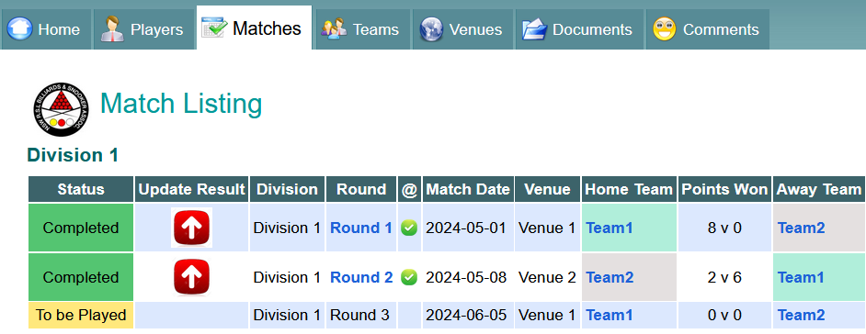



At the paper clip column

* Green tick indicates a copy of the score sheet was submitted
* Golden Star indicates match photos have been submitted

If you have a "Completed" Status and a green tick, then the result submission is completed.

You can now log off with the top right  button.



You will then be taken back to the public page where you can review the updated result and how the update effect team points and players handicap, etc.